Supported and Participatory
1. Watch this movie about the Civil War:
http://www.brainpop.com/socialstudies/freemovies/civilwar/
2. Point to 3 pictures from the movie about the Civil War.

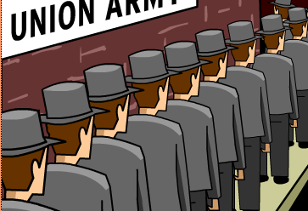 |  | 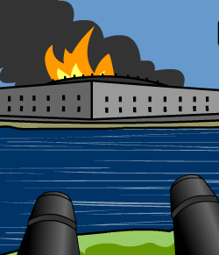
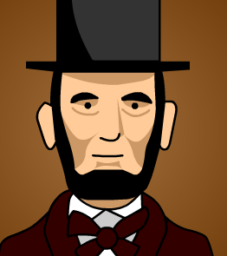
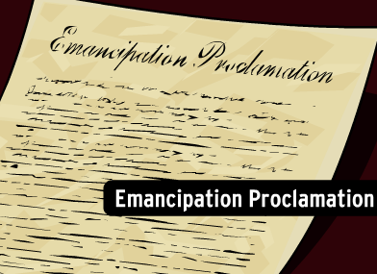 |  | 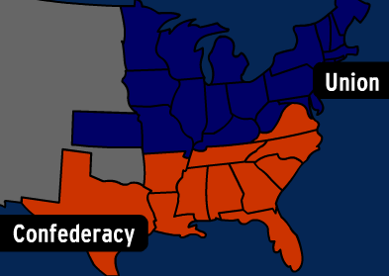
3. Read aloud to students and they answer by pointing to the correct answer.
Slavery
When people talk about slavery in North America, they usually mean African people that were used for farm work and household help. Slavery was in the North part of our country as well as the South. Over time, the Northern states didn’t need slaves as much as the Southern states. The Southern states had farms, and they needed slaves to do all of their farm work. However, all slaves became free after the end of the Civil War.
Home Life
When the Civil War started, living conditions became harder for Americans. Many of the men joined the army or were drafted. The women were left at home to work the farm or to find jobs and support the family on their own.
Many poor men thought that fighting in the army was an opportunity for adventure and excitement. This seemed much better than the hard work of every day life. They soon found out that war was both boring and terrifying.
With so many men gone to war, women had to take up new jobs. They worked the fields on farms and at factories producing goods for the armies. Some women served as nurses in the army, helping wounded soldiers recover. Women had to work very hard to provide for their families. Often not only their husbands were at war, but also their older sons and fathers.
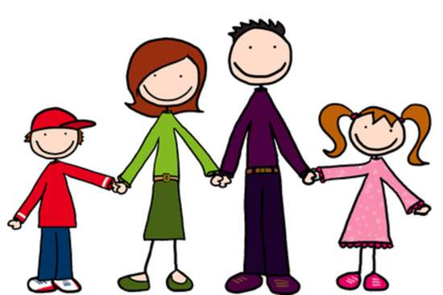 | Which one is a family?
 | Which one is a nurse?
 | Which one is a soldier in the Army? | 